
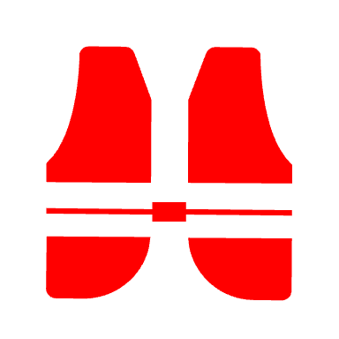
Be Safe & Sure

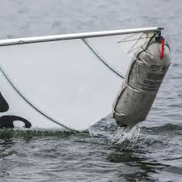

Fit a mast head buoyancy float to prevent an inversion


Check the weather

Wear the right clothing – staying warm even when wet is a confidence boost
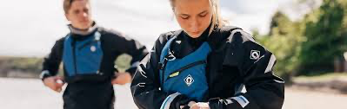
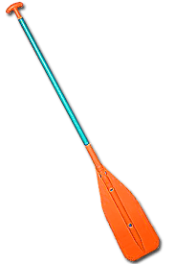

Take an alternative means of propulsion – a paddle

Make sure the bungs are in & buoyancy bags/tanks are watertight

Tell someone ashore your plans

Wave your arms up and down
Know how to call for help Whistle or shout
Use a mobile or radio

Always keep a look out – avoid a collision (learn the rules)
